SYSC 5104 Fall 2008

Assignment 2
UAV Path Planner with Probabilistic Terrain
November 18, 2008
Keith Holman, 100749416
Jeremy Kuzub, 100754498

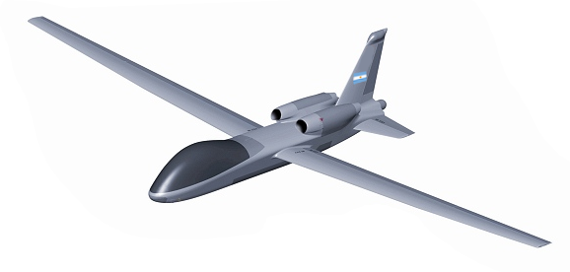

Contents
SYSC 5104 Fall 2008 1
Assignment 2 UAV Path Planner with Probabilistic Terrain 1
SECTION I: PROBLEM DEFINITION 3
OVERVIEW 3
APPLICATION OF CELLULAR AUTOMATA PAPERS TO THE PROBLEM 3
DESIGN GOALS 4
SECTION II: Cell-DEVS IMPLEMENTATION 5
Mapping Reality into the Cell Space 5
DESIGN OF SIMULATION IN CELL-DEVS 6
Overview 6
UAV : Cell-DEVS Coupled Model Formal Specification 6
Cell-DEVS Conceptual Model Definition 8
Zone “UAV-Layer” 8
Zone “DIF-Layer” 8
Zone “DIF-Layer” 8
TESTING AND EXECUTION RESULTS 9
Execution Procedure 9
Unit Test: Diffusion Rules 9
Unit Test: UAV Gradient Hill Climb 10
Full Model Test 11
Full Model Test 12
TOOLS FOR Cell-DEVS: “TerrainG” 13
BONUS MATERIAL: VISUALIZING WITH DEVS View 14
DISCUSSION 15
FURTHER DEVELOPMENT 15
REFERENCES 15

SECTION I: PROBLEM DEFINITION

OVERVIEW
Unmanned Aerial Vehicles (UAVs) are becoming increasingly common for urban and border patrols. A coming example is the Vancouver 2010 Olympics, where UAVs are expected to share civilian airspace with manned patrol vehicles in a high density urban setting. A UAVs primary task is identifying new targets, monitoring previously identified targets of interest and general surveillance. These tasks are made difficult by the limited set of information available from on-board sensors and other sources. Planning a path and determining search patterns, areas of interest and ultimately creating a route plan necessitates algorithms that can act on incomplete information.

APPLICATION OF CELLULAR AUTOMATA PAPERS TO THE PROBLEM
Our proposal applies published techniques and concepts to the UAV target search task, specifically the concept of using target location probability gradient fields. These fields could reflect probabilities of target presence, potential danger, previously searched areas, collision possibility, and other metrics. UAVs can then be modeled on a specific 2D plane as point objects with neighbours mapped to the corresponding coordinates on these gradient fields. By weighting and summing the influences from these multiple fields in a local neighbourhood around the UAV position, a route can be effectively generated. This has application to image processing tasks as well, such as threshold and edge detection.
The implementation described here is based on adapted methods described in [2] with concepts in [1] used as additional reference. Paper [1] did not contain specific algorithms descriptions to work with; however the concepts of gradient hill climbing for UAV search, and fusion of data from multiple sensor and intelligence sources into a single “target location probability terrain” were deduced. Paper [2] contains algorithms that in simplified or generalized form can be convertible to Cell-DEVS. Specifically one for processing target uncertainty using Cellular Automata (CA) and creating a path plan using a separate rule set that then uses this potential field as input. Some concepts of UAV communication did not use a CA model; however, the idea of implicit multi-UAV communication was made implicit in our adaptation if UAVs share the same target location probability map.
The rule set for a given UAV cell would is initially approximated by a hill-climbing algorithm – move to local cell that has the highest level. An additional rule would apply in a tie condition, such as when there is no indication of a preferred routing direction. Target areas and specific targets are modeled as “hills” of increasing numerical value in a separate 2D plane. For example, a target area with a given probability of a target in that area will modeled as a 2D Gaussian function with corresponding parameters for distribution. A known target would be a very sharp spike up to a maximum probability.

DESIGN GOALS
- Provide a probabilistic model of UAV target location – in practice, a UAV is searching for a target that does not have a known location; however various sources of information about probable target location may be available. A design goal is to represent this fused data as a ‘terrain’ whose ‘altitude’ values reflect the probability that the target is in any one location.
- Provide a UAV path planning algorithm that allows effective search of the cell space based on target location probabilities – this would most likely be a ‘Hill Climb’ algorithm in which the UAV would move to the neighbouring cell location with the greatest target location probability.
- Provide a method of defining UAV movement boundaries. In deployment, some areas are prohibited for UAV travel, such as populated areas, obstacles, or other search zones. This boundary was ultimately mapped to a dedicated 2D layer.
- Design and build an external to program to generate initial sample probability gradient maps. This would allow fast and efficient generation of test cases. This was ultimately implemented in C++ as the “TerrainG” application.
- Model the change in the target location probability over time due to target movement. This reflects the ‘aging’ of intelligence and sensor data over time as a spreading of high probability values to adjacent areas, reflecting movement of a vehicle or other target while not under observation.
- Model the change in the target location probability map based on UAV over-flight. This would ultimately allow multiple UAVs to implicitly coordinate a search if they were using a continuously updated, shared target location probability map.

SECTION II: Cell-DEVS IMPLEMENTATION

Mapping Reality into the Cell Space

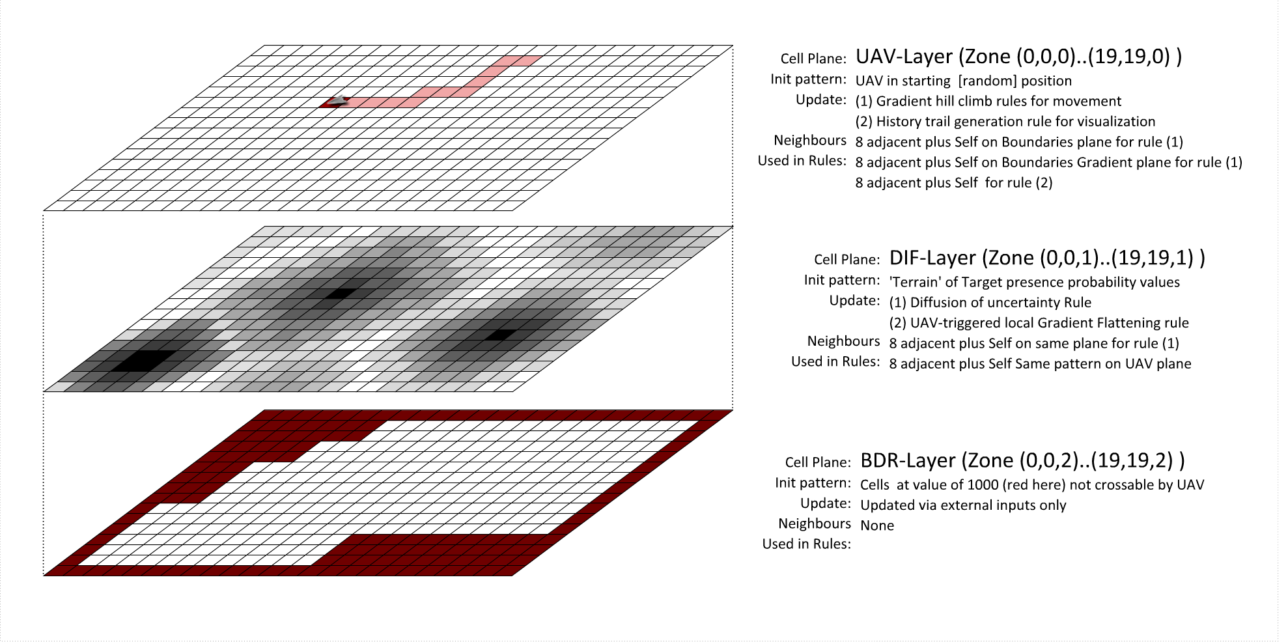
Figure 1: Cell-DEVS encoding of UAV search problem
The transform from the reality of a UAV exploring terrain to a Cell-DEVS model included the following assumptions and mappings:
- The 3D cell space was divided into three 2D layers. Layer 0 stored UAV position and previous travel path. Layer 1 stored the Target Location Probability Terrain or “gradient”. Level 2 stored the UAV “no-go” boundary information.
- The cell space was assigned a dimension of 2000 meters by 2000 meters, for a coverage area for this UAV of 4km². This size would apply to a mini-UAV, such as the ones under development for ‘back pack’ deployment by soldiers or rescue teams.
- Cell size – this was mapped to 100 meters by dividing UAV travel speed by rate of sensor sweeps per second for a constant search altitude of 1000 meters. This allows the model to represent UAV travel at one cell per bases simulation period (1000) without skipping or loitering in a given cell.
- Target location probability diffusion rate varies with the speed of the target. Although a target is implicitly defined by probabilities in this simulation, the diffusion rate reflects the speed and unpredictable movement of the target. In this case it was modeled as a ground vehicle with a speed of 10 meters per second. Target diffusion is not direction-preferential in this simulation as target direction or vector information is assumed to be unknown.

DESIGN OF SIMULATION IN CELL-DEVS

Overview
Using 3 separate Zones to separate rule sets for the UAV, Gradient and Boundary required the formal Cell-DEVS specification to include a neighbourhood that was a superset of all relevant neighbour sets. This became a 3x3x3 cell space, which is specified here. Addition specification based on cell values is listed as notes within this specification.

UAV : Cell-DEVS Coupled Model Formal Specification

M=<I,X,Y,Xlist,Ylist,η, N,{m,n}, C, B, Z, Select>
Xlist=Φ
Ylist=Φ
η=27
I=<P^{X},P^{y} ,P^{Z} >,with P^{X}={Φ},P^{y}={Φ},P^{Z}={Φ};
N={ (1,-1,0), (1,0,0), (1,1,0),
(0,-1,0), (0,0,0), (0,1,0),
(-1,-1,0),(-1,0,0),(-1,1,0),

(1,-1,1), (1,0,1), (1,1,1),
(0,-1,1), (0,0,1), (0,1,1),
(-1,-1,1),(-1,0,1),(-1,1,1),

(1,-1,2), (1,0,2), (1,1,2),
(0,-1,2), (0,0,2), (0,1,2),
(-1,-1,2),(-1,0,2),(-1,1,2)}

X=Y= {1, ... ,8,50,100}¹ ∧
{ 0, ... , 999 }² ∧
{ 0, 1000 }³

¹ This applies to the UAV zone, which is the 2D plane at depth=0 (“UAV zone”). 1..8 indicates pending UAV move direction, 100 indicates current UAV position, 50 indicates cell has had past UAV occupancy

² This applies to the Target Location Probability zone, which is the 2D plane at depth=1 (“Gradient zone”). This can be any positive real number up to the maximum specified.

³ This applies to the prohibited Boundary zone, which is the 2D plane at depth=2 (“Boundary zone”). A value of 1000 indicates that the UAV cannot enter the corresponding cell on the UAV plane.

m=20; n=20;
B={Φ};
C={Cij/iε[1,20], jε[1,20]}
Z:
P_{ijk} Y1 → P_{i-1,j-1,k} X1 P_{i-1,j-1,k} Y1 → Pij X1
P_{ijk} Y2 → P_{i-1,j,k} X2 P_{i-1,j,k} Y2 → Pij X2
P_{ijk} Y3 → P_{i-1,j+1,k} X3 P_{i-1,j+1,k} Y3 → Pij X3
P_{ijk} Y4 → P_{i+1,j-1,k} X4 P_{i+1,j-1,k} Y4 → Pij X4
P_{ijk} Y5 → P_{i+1,j+1,k} X5 P_{i+1,j+1,k} Y5 → Pij X5
P_{ijk} Y6 → P_{i+1,j,k} X6 P_{i+1,j,k} Y6 → Pij X6
P_{ijk} Y7 → P_{i,j-1,k} X7 P_{i,j-1,k} Y7 → Pij X7
P_{ijk} Y8 → P_{i,j+1,k} X8 P_{i,j+1,k} Y8 → Pij X8
P_{ijk} Y9 → P_{i,j,k} X9 P_{i,j,k} Y9 → Pij X9

P_{ijk} Y10 → P_{i-1,j-1,k+1} X1 P_{i-1,j-1,k+1} Y10 → Pij X10
P_{ijk} Y11 → P_{i-1,j+1,k+1} X11 P_{i-1,j+1,k+1} Y11 → Pij X11
P_{ijk} Y12 → P_{i-1,j,k+1} X12 P_{i-1,j,k+1} Y12 → Pij X12
P_{ijk} Y13 → P_{i+1,j-1,k+1} X13 P_{i+1,j-1,k+1} Y13 → Pij X13
P_{ijk} Y14 → P_{i+1,j+1,k+1} X14 P_{i+1,j+1,k+1} Y14 → Pij X14
P_{ijk} Y15 → P_{i+1,j,k+1} X15 P_{i+1,j,k+1} Y15 → Pij X15
P_{ijk} Y16 → P_{i,j-1,k+1} X16 P_{i,j-1,k+1} Y16 → Pij X16
P_{ijk} Y17 → P_{i,j+1,k+1} X17 P_{i,j+1,k+1} Y17 → Pij X17
P_{ijk} Y18 → P_{i,j,k+1} X18 P_{i,j,k+1} Y18 → Pij X18

P_{ijk} Y19 → P_{i-1,j-1,k-1} X19 P_{i-1,j-1,k-1} Y19 → Pij X19
P_{ijk} Y20 → P_{i-1,j+1,k-1} X20 P_{i-1,j+1,k-1} Y20 → Pij X20
P_{ijk} Y21 → P_{i-1,j,k-1} X21 P_{i-1,j,k-1} Y21 → Pij X21
P_{ijk} Y22 → P_{i+1,j-1,k-1} X22 P_{i+1,j-1,k-1} Y22 → Pij X22
P_{ijk} Y23 → P_{i+1,j+1,k-1} X23 P_{i+1,j+1,k-1} Y23 → Pij X23
P_{ijk} Y24 → P_{i+1,j,k-1} X24 P_{i+1,j,k-1} Y24 → Pij X24
P_{ijk} Y25 → P_{i,j-1,k-1} X25 P_{i,j-1,k-1} Y25 → Pij X25
P_{ijk} Y26 → P_{i,j+1,k-1} X26 P_{i,j+1,k-1} Y26 → Pij X26
P_{ijk} Y27 → P_{i,j,k-1} X27 P_{i,j,k-1} Y27 → P_{i,j,k-1} X27

Select={(-1,-1,0),(-1,0,0),(-1,1,0),(0,-1,0),(0,0,0),(0,1,0),(1,-1,0),
(1,0,0),(1,1,0) }

Cell-DEVS Conceptual Model Definition
See Figure 1 for reference to cell space and Zones. The 3D cell space was divided into three 2D slices using the “Zone” method. Layer 0 stored UAV position and previous travel path. Layer 1 stored the Target Location Probability Terrain or “gradient”. Level 2 stored the UAV “no-go” boundary information.

Zone “UAV-Layer”
This zone stores UAV position and the rules act to move the UAV using a hill-climb algorithm with DIF-Layer as a data source.
If a UAV is in the current cell, rules 1-8 use a nested “max” macro to determine compare the relative values of neighbouring cells on the DIF-Layer and change the cell value to a ‘pending move’ value of 1-8 representing direction of pending UAV movement. Detection of a value of 1000 on the BDR-Layer is used as a flag to prohibit movement in a boundary area.
Rules 9-16 execute UAV movement if the current cell has a neighbour that contains a ‘pending move’ value that is ‘pointed’ at it.
Rule 17 converts the current UAV position of 100 into a ‘UAV visited’ value of 50 to provide UAV visual history tracking.
Rule 18 maintains a non occupied cell to default value of 0.

Zone “DIF-Layer”
The diffusion of Target Location Probability is handled by a single rule that changes the current cells value based on an average of neighbouring cell values in the same Zone. This change is slowed using a ‘viscosity’ divisor that can be increased to slow the diffusion rate. Diffusion has no preferential direction.
Rule 2 acts to reduce the target location probability to zero if the corresponding cell in the UAV-Layer Zone is occupied by a UAV (value of 100). This models a UAV passing overhead and scanning the area.

Zone “BDY-Layer”
The boundary layer remains static throughout a simulation, although it is feasible to use events to change the boundaries and affect UAV pat planning. A value of 0 indicates a UAV can move to the corresponding cell in its zone, and a value of 1000 indicates the UAV is prohibited from crossing into the corresponding cell in its Zone.

TESTING AND EXECUTION RESULTS
All tests were conducted my developing a dedicated set of .MA, .BAT, .PAL, and .VAL files. The results were converted to .DRW files for viewing in the Cell-DEVS animation tool with a customized palette.

Execution Procedure
Within the DEVS++ view of Eclipse, create a new project and import the load the uavProbability.zip archive. “uav.ma” is the Full model with “diffusionTest.ma” a unit test of the diffusion rules and “uavTest.ma” a unit test of the UAV hill climb rules. Running the corresponding .BAT file (example: “uav.bat”) generates a log file which is viewable in CellDEVS Animator.

Unit Test: Diffusion Rules
The “Diffusion.*” files were used in this test. DiffusionTest.BAT automatically generates a new random hill terrain using TerrainG with parameters defined in “DiffusionTest.ini”.
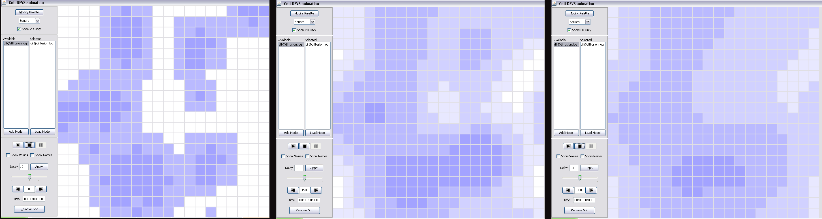
Figure 2: Results of the Probability diffusion rules at three times during simulation.
Testing of the Target Location Probability diffusion rule was carried out independently to validate the spread of high-probability ‘mountains’ to low probability ‘valleys’. It was found through testing that a local average of neighbour cell values caused this process to be too rapid, so a ‘viscosity’ term was added to the rule, effectively slowing down the diffusion process by modifying each cell by some fraction of the difference between its value and neighbouring cell values. Testing was successful and this sub model behaved as expected.

Using an Event File to Simulate Outside Intelligence
To simulate an update in target location data an effect file was used to change values in the gradient layer. This simulates data that a UAV may receive from outside sources (example: human intelligence, satellites, or other UAVs). This technique could be used to create preferential paths for the UAV to follow.

Unit Test: UAV Gradient Hill Climb
The “UAVTest.*” files were used in this test. “UavTest.bat” uses TerrainG with parameters defined in “UavTest.ini” to generate random hill terrain for each test run.
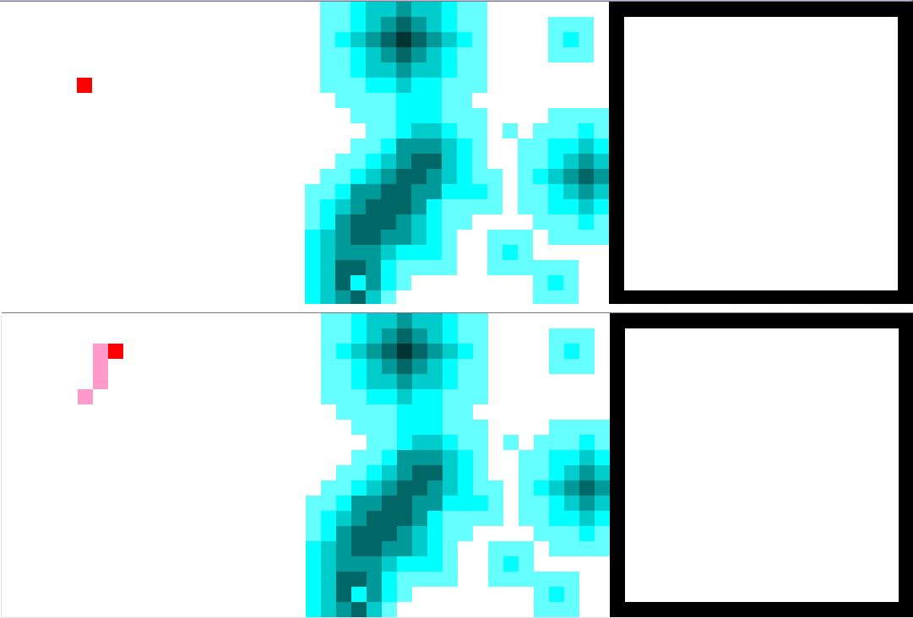
Figure 3: UAV Hill Climb rule test using static terrain. The UAV is shown to successfully climb the nearest ‘hill’ and enter a limit cycle oscillation around its highest point.
The UAV hill climb rule operates in three steps. First, a rule set determines the neighbouring cell with the highest target location probability and sets the current UAV location cell to a value which represents pending movement (1=East, 2=North etc.). The second simulator step completes the movement by scanning neighbouring cells for a ‘pending movement’ value that ‘points’ in the current cell’s direction, causing that cell to be assigned a ‘UAV present’ value. A final step removes residual ‘pending movement’ values from the Zone.
This hill climb was tested using the “TerrainG” application which was developed to quickly generate smooth terrain for testing the Hill Climbing algorithm. The .VAL files generated by “TerrainG” specified the gradient zone values which the UAV hill climb rules used, and the diffusion rules were disabled to maintain a stable probability terrain. Viewing the results Cell-DEVS animation tool showed the hill climbing algorithm functioned as expected.

Full Model Test
The files “uav.*” were used in this test. “UavNoFlyZone.val” can be renamed “uav.val” and run with the “uav.bat” file to generate the results below, which contain a unique “no-go” island in the middle of the cell space. Otherwise, “UavGenerateTerrain.bat” can be run to generate a new “uav.val” file which is then used by “uav.bat” to run a new randomized simulation using ‘uav.ma’ and outputting “uav.log”. “UavDRW.bat” will generate the .DRW output if desired.
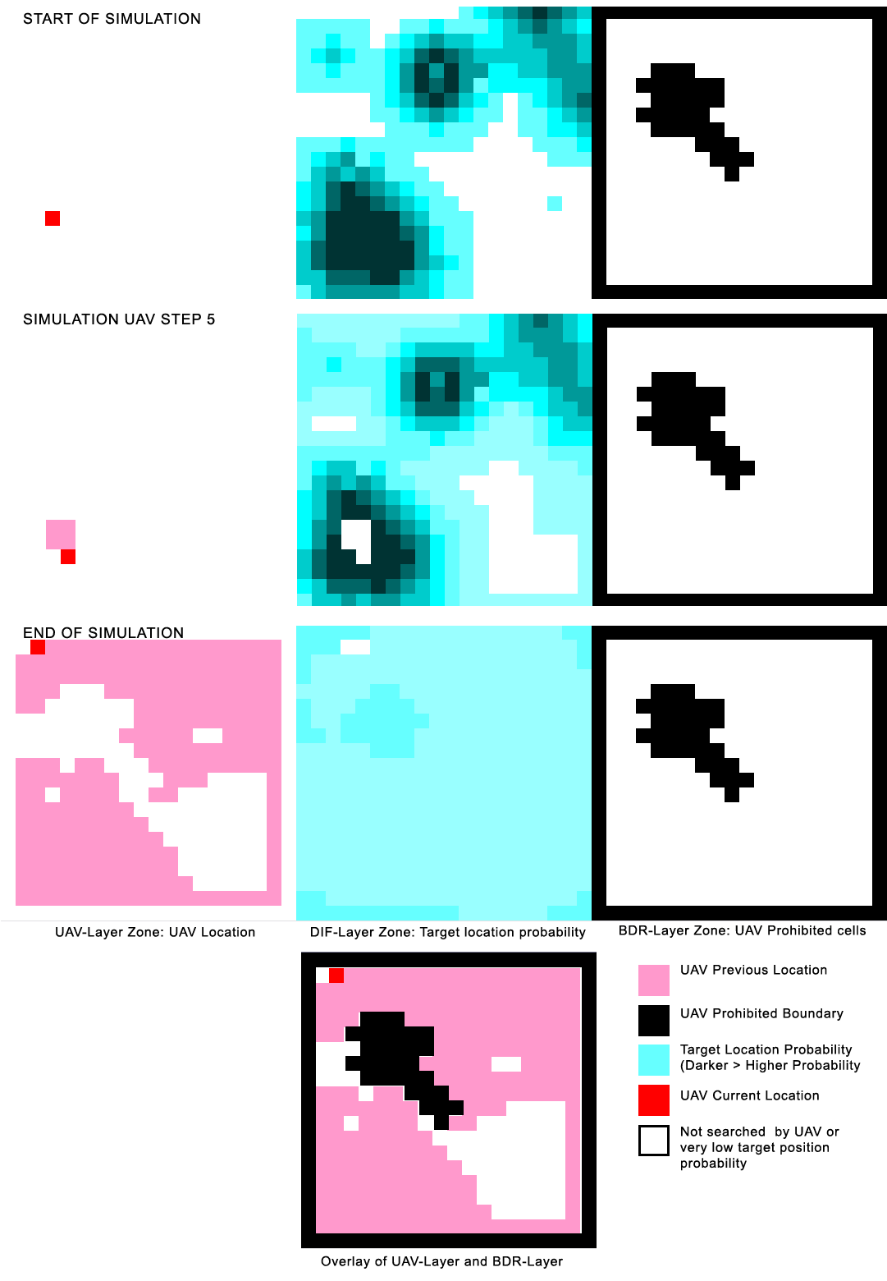
Figure 4: Testing the full UAV rule set with edge and 'village' no-go boundaries and initial terrain generated by the custom “TerrainG” tool. The next row is Simulation Step 5, showing the UAV searching the local high-probability area firs; later it moved to the top right area while avoiding the high probability ‘no-go’ village area. The last image overlay shows that the UAV avoided the no-go areas as expected. The relatively 'flat' DIF-Layer at the end of simulation indicates that the simulation has run for some time.

Full Model Test
In this test, all rules were active. It was tested by adding a 1-cell boundary around the cell space, eliminating and requirement for special edge detection or wrapping rules. An additional ‘island’ of prohibited area was added near the center of the cell space t represent an obstacle or village where flyovers are prohibited or dangerous. The UAV was then tested over an extended simulation time to determine:
- If any incursions took place: the rules operated as expected and no incursions took place either on the boundaries or across the ‘village’ area
- Hill climb rules for UAV – these operated as expected with the UAV consistently moving in the direction of greatest increase in target probability as represented in the Target Location Probability layer.
- Diffusion of Probability Rules – these operated successfully, resulting in a flatter terrain over time. The terrain was also successfully flattened to zero target probability directly ‘under’ the UAV as desired.
- Overall UAV search pattern – The resulting search pattern was effective at locating local maxima of Target Probability and thoroughly searching those areas without re-crossing paths. This is relatively complex behaviour defined as simple rule set. Additionally, the Diffusion of Target Probability had the additional positive feature of the constantly providing a gradient for the UAV to ‘climb’, even from distant targets. This had the benefit of keeping the UAV from staying near a local maximum, leading to a thorough search of the majority of the cell area from most-to-least probable Target location areas.
Overall, the showed remarkably complex emergent UAV paths that had efficient local search behaviour, typically climbing to a local maxima then spiralling out from it to lower probabilities until the diffusion effect created a gradient to more distant maxima, which would subsequently be climbed. The successfully UAV ignored high probability areas within ‘no-go’ boundary areas as expected.

TOOLS FOR Cell-DEVS: “TerrainG”
A custom C++ tool was developed to generate continuous smooth terrain using a configuration text file as input and generating a Cell-DEVS usable .VAL file as output. The size of the cell space, number of peaks, the maximum and minimum cell values, default cell value, iteration count (smoothness). An Example input file is seen below:
x=20 % cell space size
y=20
min=0 % default cell min and max values
max=20
default=0 % cell default value

[Layer.1] % 3D layer 1 configuration:
generator=Random % type of positional generator (random|hills|border)
% random indicates random points, such as UAVs
count=1 % number of features to generate
min=100 % cell min and max values
max=100
z=0 % cell layer depth number

[Layer.2] % 3D layer 2 configuration
generator=Hills % Hills derives smooth terrain
count=15
min=1
max=7
z=1

[Layer.3] % 3D layer 3 configuration
generator=Border % border creates a boundary 1 cell wide at the
% perimeter of the cell space using the max value
max=1000
z=2


Figure 5: TerrainG resulting .VAL file based on the above input file and the resulting sample. UAV layer is on left, followed by the terrain layer and the border layer.
The TerrainG file and sample input files are included in the assignment distribution zip. These include:

BONUS MATERIAL: VISUALIZING WITH DEVS VIEW
DEVS View was launched and successfully opened the uav.ma file and a uavBonus.log file to generate uavDV.vis. Using the VIS_EL and VIS_ML commands confirmed that events were successfully loaded and that the UAV model was loaded from the uav.ma file. This reflects Steps 1 through 18 of the procedures outlined in section 8.3.1 of the DEVS View tutorial. Running the simulation in DEVS View showed no transition changes.
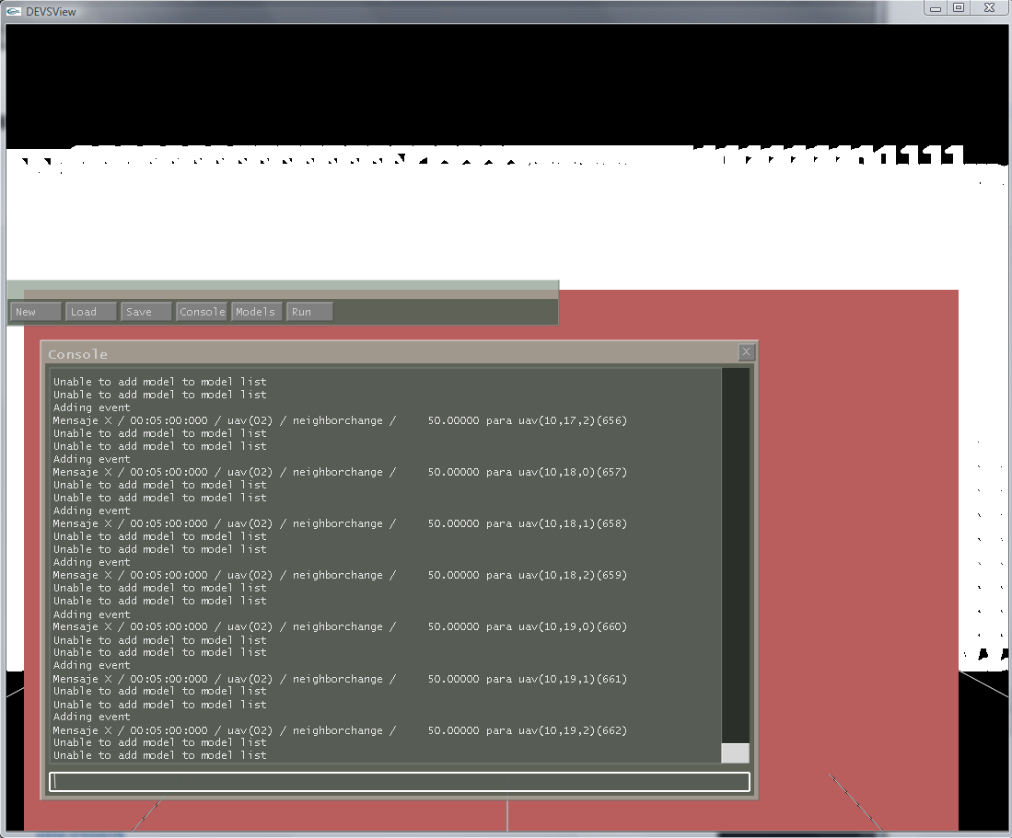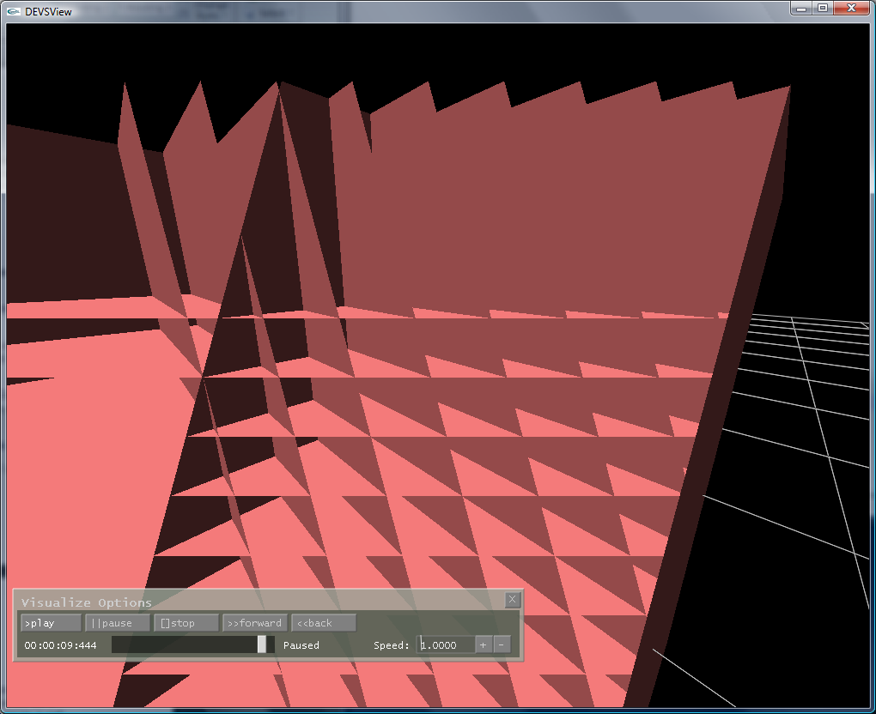

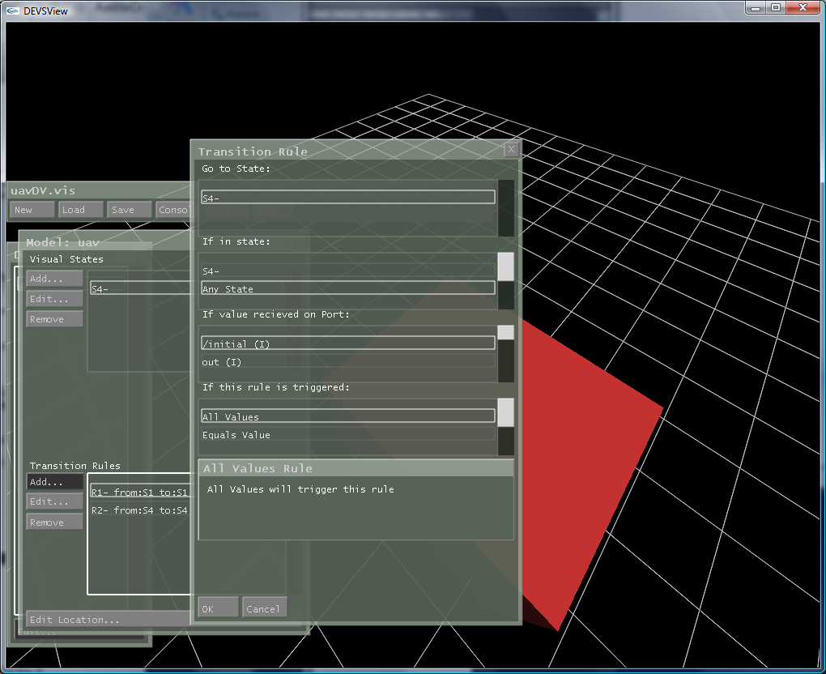

DISCUSSION
The simulation works as expected and yielded surprisingly ‘intelligent’ UAV search patters despite the highly localized neighbourhoods and simple behavioural rules. Diffusion was an effective method of representing the ‘aging’ of data, and allowed the UAV to ultimately search the majority of the cell space, with a priority on local maxima of target location probability. The concept of “flattening” the target location probability ‘under’ the UAV acted to automatically move the UAV into an effective and non repetitive search pattern. Boundaries acted to contain and limit the UAV search. The “TerrainG” tool was effective in generating new randomized test cases for rapid testing and verification, and can be used in other Cell-DEVS projects that require various randomized 3D or 2D cell spaces to be rapidly generated as .VAL files.

FURTHER DEVELOPMENT

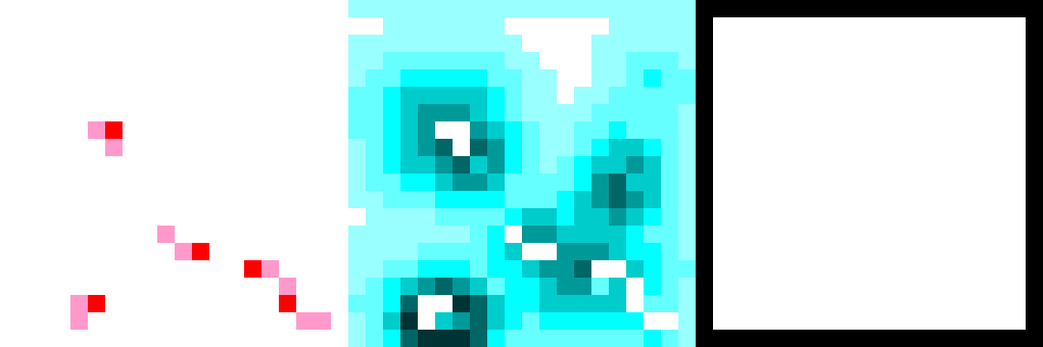
Figure 6: Using 4 UAVs on the UAV plane. Cooperation is carried out implicitly since they share the same target location probability Layer as input. Further development in collision detection and avoidance would be required.
This architecture allows the use of multiple UAVs searching the same target location probability terrain in a coordinated fashion. There will not be repetition of search patterns since each UAV interacts with localized area and ‘modifies the target probability terrain when passing over. Additional neighbourhood patterns could be simulated and preferred target movement paths could be modeled, reflecting roads and population areas.

REFERENCES
- Andrew Shem, Thomas Mazzuchi, Shahram Sarkani, Addressing Uncertainty in UAV Navigation Decision-Making, IEEE Transactions on Aerospace and Electronic Systems Vol. 44, No. 1 January 2008
- Ira Glickstein, Peter Stiles, Situation Assessment Using Cellular Automata Paradigm, IEEE AES Systems Magazine, January 1992

